Dear Parents, 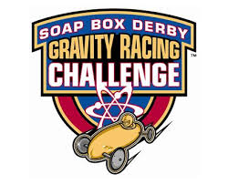

This spring, SAMS will be taking a team of 7th graders to compete in the All-American Soap Box Derby Gravity Racing Challenge in Akron, Ohio. Your son/daughter has an opportunity to apply and interview for one of the limited places on this extraordinary team.

The Gravity Racing Challenge (GRC) consists of the construction, testing, and racing of a super-stock soap box derby car. Construction will involve meeting with your team and coaches approximately once-a-week during March and April for about an hour immediately after school. During these meetings, we will be building and tuning the super-stock car following the All-American Soap Box Derby (AASBD) guidelines. This project will teach students about working as a team, basic physics concepts, and various areas of STEM (Science, Technology, Engineering, and Math).

On May 6th, our team will spend one day testing at the AASBD racing facility in Akron. The official Gravity Racing Challenge is scheduled for Saturday, May 14th. Transportation of team members to and from these events is the responsibility of their parents. South Amherst Middle School assumes no liability for transportation.

For detailed information regarding the competition, visit the official AASBD webpage at the following link and click on the education tab:

http://www.soapboxderby.org

Applications are due February 18th with top applicants being interviewed during the days to follow within the school day.

Sincerely,

C. Latto (clatto@firelandsschools.org)
C. Pelphrey (cpelphrey@firelandsschools.org)
A. Swift (aswift@firelandsschools.org)
SAMS AASBD GRC Team Coaches

